*Content of Report*

**Abstract of Project:** (1 paragraph not more than 300 words) **–Brief description of Project.**

…intro on need for nutrient management. We propose to develop an application that uses the leaf images of crops like rice, wheat and maize to identify nutrient deficiencies like Potassium,Magnesium,Zinc,Iron,Manganese,Copper,Boron,Sulphur,Nitrogen deficiency levels (only for rice) and recommend appropriate fertilizer/nutrient management techniques.

**System Analysis or Requirement Analysis**

**The overall process of project – diagram and description.**

**Mapping of requirements to the subsystems or modules chosen.**

**Functionalities of the system and Subsystem.**

for rice

Home page – description and navigation to individual pages

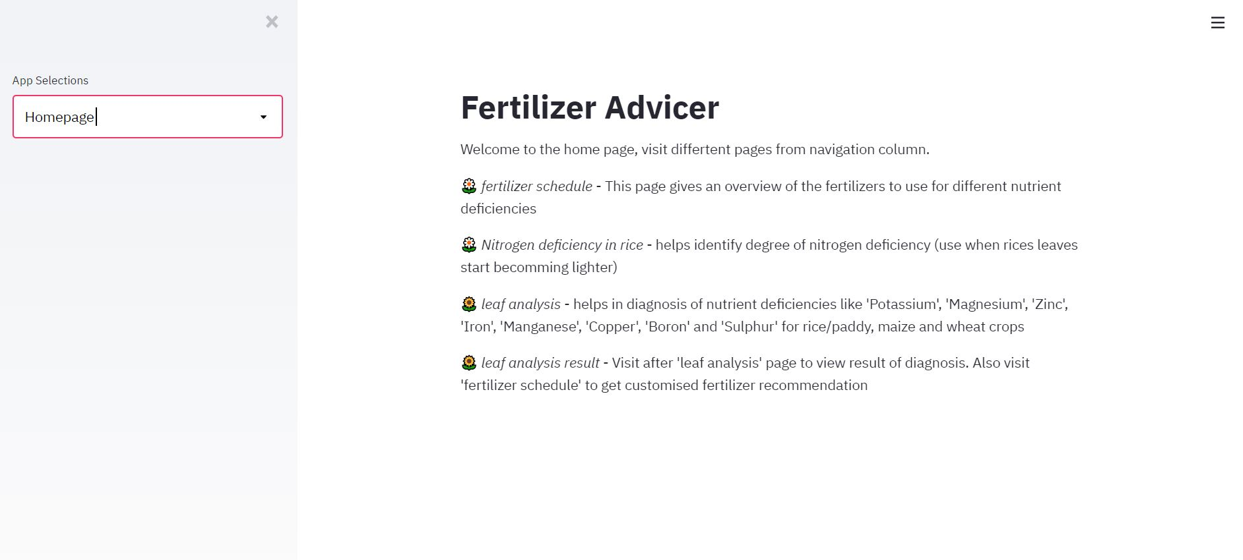

Figure Home page

fertilizer schedule - This page gives an overview of the fertilizers to use for different nutrient deficiencies

-Select land size

- Stage of growth (sapling/established/flowering)

-Crop type (rice/maize/wheat)

Defalut shows fertilizers recommended for all nutrients deficiencies focused on.

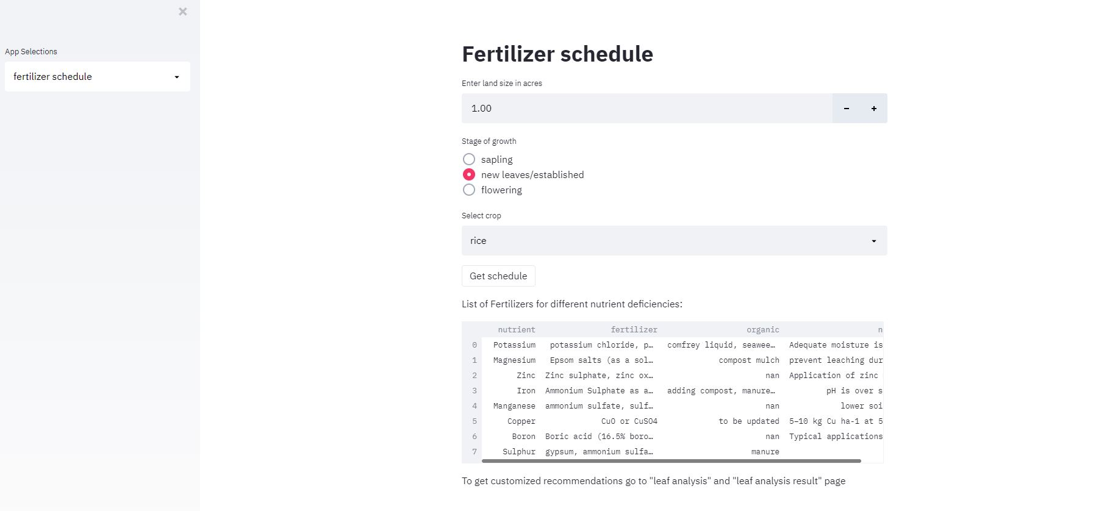

Figure General Fertilizer schedule for all nutrients

Nitrogen deficiency in rice - helps identify degree of nitrogen deficiency (use when rices leaves start becomming lighter)

Option to upload rice leaf image (taken in white background)

Neural network model run on backend to classify the image into (1 of 4, 'swap1','swap2','swap3','swap4) categories based on the Leaf Color Chart for rice.

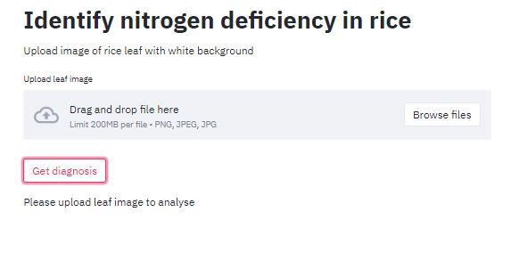

Figure Pae to upload image of rice leaf for nitrogen deficiency detection

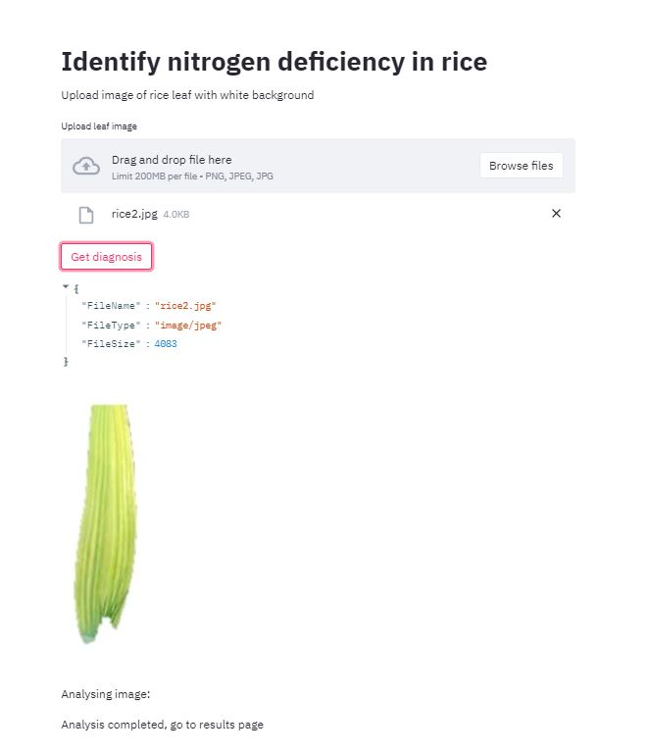

Figure Page after uploading image

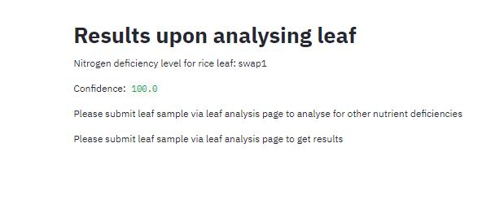

Figure Model results for uploaded rice leaf

leaf analysis - helps in diagnosis of nutrient deficiencies like 'Potassium', 'Magnesium', 'Zinc', 'Iron', 'Manganese', 'Copper', 'Boron' and 'Sulphur' for rice/paddy, maize and wheat crops

* Choose age of leaf (mature/old, new/young, middle)
* Choose crop (r,w,m)
* Upload image of leaf with white background
* Click button to get diagnosis
  + Nn model trained to classify an image into the following categories (normal, spotty, margin, interveinal, tip) is run
  + 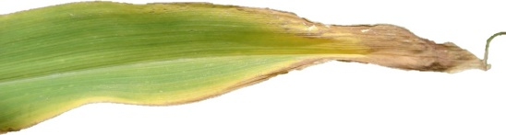

Figure Image of Maize leaf with label as tip

Figure Image of wheat leaf with label as spotty



Figure Wheat leaf with label as normal

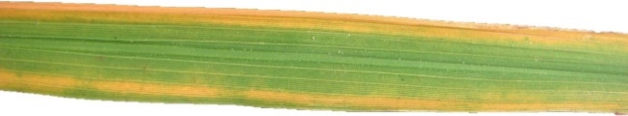

Figure Rice leaf with label as margin

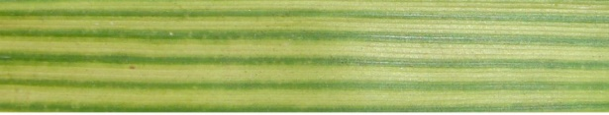

Figure Maize leaf with label as interveinal

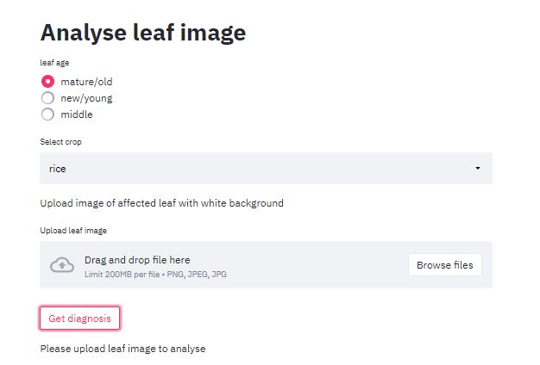

Figure PAge to upload leaf image and select crop details

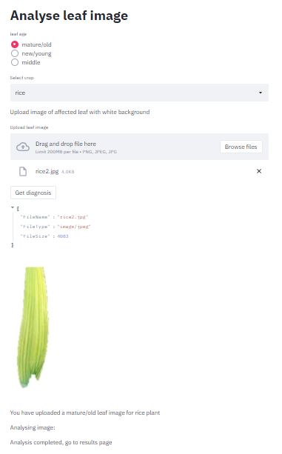

Figure PAge after uploading image

leaf analysis result - Visit after 'leaf analysis' page to view result of diagnosis. Also visit 'fertilizer schedule' to get customised fertilizer recommendation

Here some human input is collected to further specialize the classification. General question about plant asked:

-Does the plant show stunted growth

- Are there Red/dead spots on leaves

- Are the leaves twisted/brittle

- Is there a general yellowing of leaves observed

Along with answers to these questions and the results of the modle, nutrient deficiey if identified is displayed.

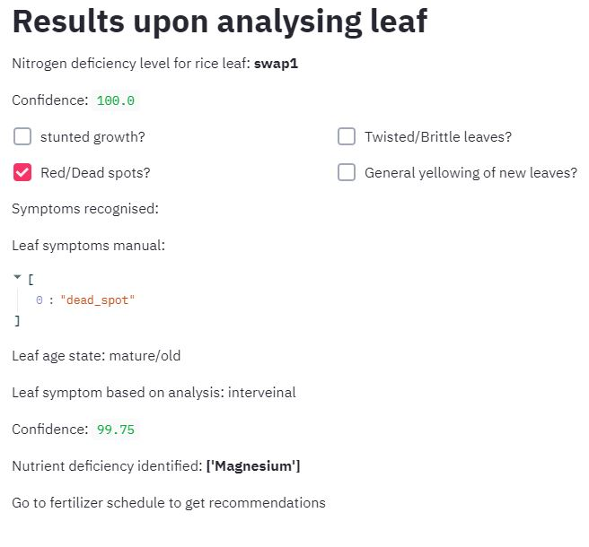

Figure Results page where the machine learning model results are displayed and the nutrient deficiencies are diagnosed



Figure Message displayed when result page accessed before uploading image

The user can now navigate back to the fertilizer recommendation page to get the customised data on which fertilizers to use.

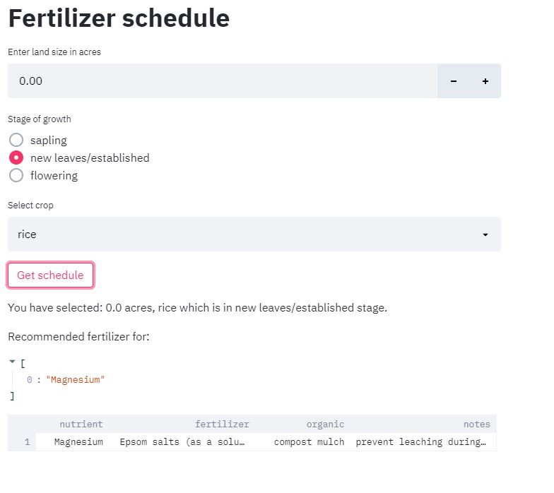

Figure Customised fertilizer recommendation based on model results

Figure Logic for diagnosing nutrient deficiency

**System Design**

**Architectural design – Level 0 DFD or block diagram showing the system and its subsystem.**

**Tensorflow lite model for rice lcc (mobile application also available)**

**Streamlit – python app for front end**

**Database – CSV files to store nutrient – fertilizer data**

**TensorFlow – Keras neural network model – for leaf classification**

**The** Neural network model for all other nutrient prediction:

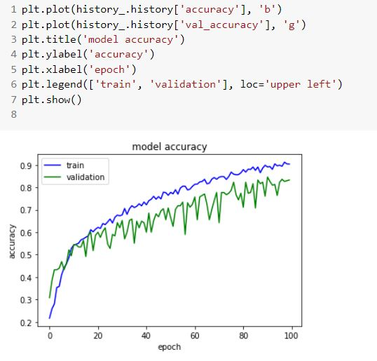

Figure 19Increase in accuracy when training for 100 epochs

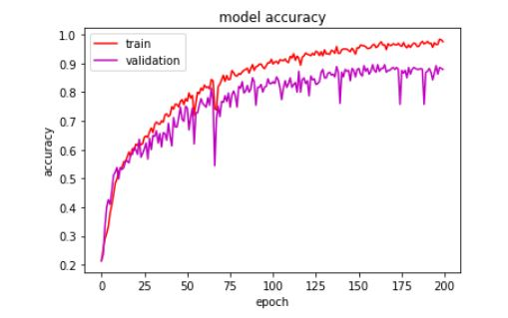

Figure 20 Increase in accuracy when training for 200 epochs

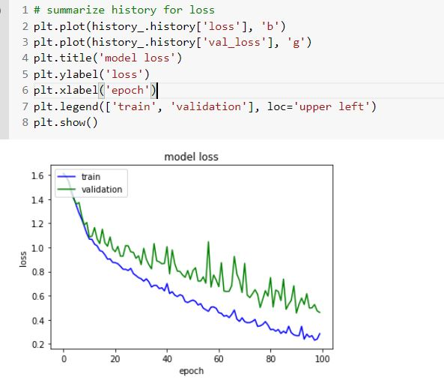

Figure 21 Decrease in loss when training for 100 epochs

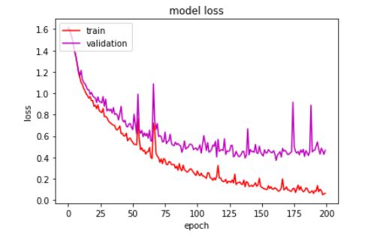

Figure 22 Decrease in loss when training for 200 epochs

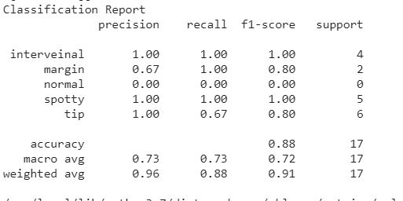

Figure 23Classification report for trained model

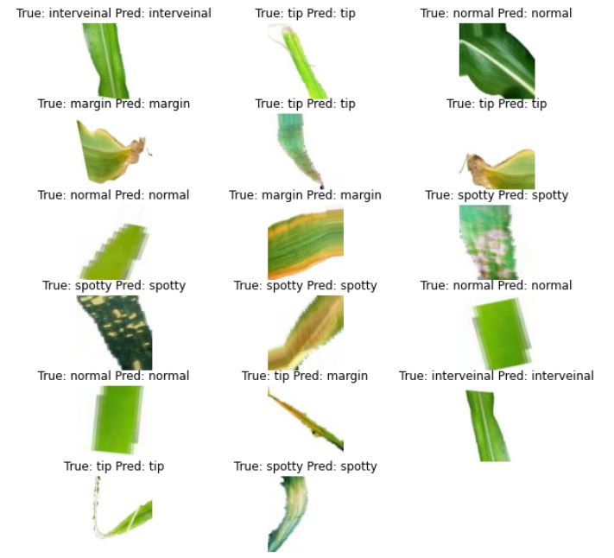

Figure 24Examples of model predictions along with true labels

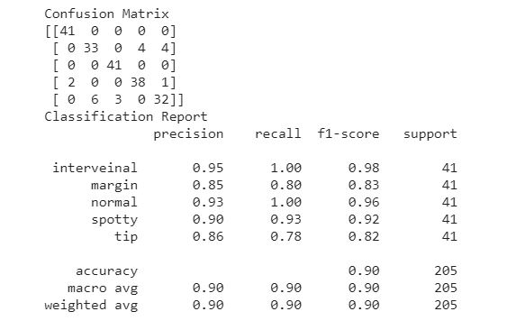

Figure 25Final model confusion matrix and classification report

Train, Validation accuracy = 90%

Final Test accuracy = 88.24%

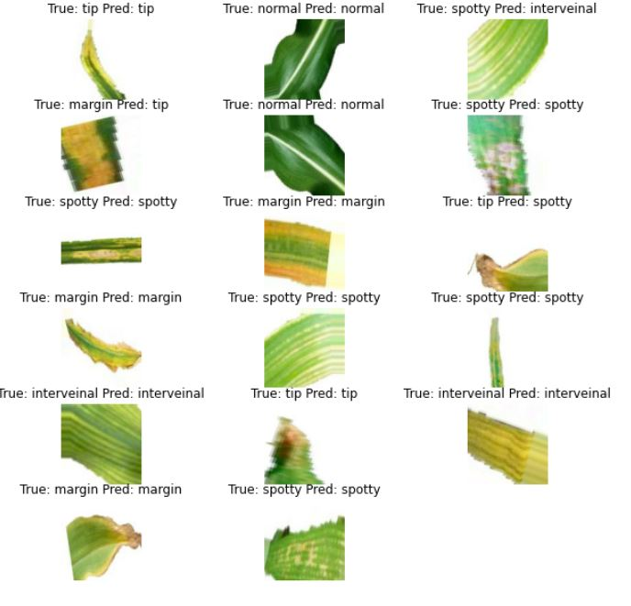

Figure 26 PRedictions and true labels for model trained with 100 epochs

Dataset:

Found 1530 files belonging to 5 classes. – Train data

Found 305 files belonging to 5 classes. – Validation data

Found 205 files belonging to 5 classes. -Test data

Model structure:

Preprocesing – Rescale image pixel values

Convolution layer – 32 filters, stride 3, activation = ReLU

MAxPool laver

Convolution layer – 64 filters, stride 5, activation = ReLU

MAxPool laver

Dropout Layer (drop 50% of nurons)

Convolution layer – 64 filters, stride 5, activation = ReLU

MAxPool laver

Dropout Layer (drop 50% of nurons)

Convolution layer – 64 filters, stride 5, activation = ReLU

MAxPool laver

Dropout Layer (drop 40% of nurons)

Dense layer – 128 nuerons, activation = ReLU

Dense layer = 5 nuerons, activation = softmax

Optimizer = SGD (Stochastic Gradient descent)

Loss function = Categorical cross entropy

**Component design – level 1.. n DFD where each level reveal the details or if the project is Object oriented design then can be specified using Class diagram.**

Home page – description and navigation to individual pages

fertilizer schedule - This page gives an overview of the fertilizers to use for different nutrient deficiencies

-Select land size

- Stage of growth (sapling/established/flowering)

-Crop type (rice/maize/wheat)

Defalut shows fertilizers recommended for all nutrients deficiencies focused on.

Nitrogen deficiency in rice - helps identify degree of nitrogen deficiency (use when rices leaves start becomming lighter)

Option to upload rice leaf image (taken in white background)

Neural network model run on backend to classify the image into (1 of 4, 'swap1','swap2','swap3','swap4) categories based on the Leaf Color Chart for rice.

leaf analysis - helps in diagnosis of nutrient deficiencies like 'Potassium', 'Magnesium', 'Zinc', 'Iron', 'Manganese', 'Copper', 'Boron' and 'Sulphur' for rice/paddy, maize and wheat crops

* Choose age of leaf (mature/old, new/young, middle)
* Choose crop (r,w,m)
* Upload image of leaf with white background
* Click button to get diagnosis
  + Nn model trained to classify an image into the following categories (normal, spotty, margin, interveinal, tip) is run

leaf analysis result - Visit after 'leaf analysis' page to view result of diagnosis. Also visit 'fertilizer schedule' to get customised fertilizer recommendation

Here some human inut is collected to further specialize the classification. General question about plant asked:

-Does the plant show stunted growth

- Are there Red/dead spots on leaves

- Are the leaves twisted/brittle

- Is there a general yellowing of leaves observed

Along with answers to these questions and the results of the modle, nutrient deficiey if identified is displayed.

fertilizer schedule - This page gives an overview of the fertilizers to use for different nutrient deficiencies

-Select land size

- Stage of growth (sapling/established/flowering)

-Crop type (rice/maize/wheat)

Defalut shows fertilizers recommended for all nutrients deficiencies focused on.

**Behavioral design – process diagrams or if the project is Object oriented design then can use sequence diagrams.**

Figure User flow diagram

**References: (IEEE format) – what you referred?**

*Note: The gray colored text is the hint of what information is expected in that section*

**Common guidelines for preparing Synopsis**

* Each page should have header and footer
  + Header – Project Name (LHS) and Page No (RHS)
  + Footer - BMSIT&M, Dept Name(LHS) and year of submission(RHS)
* Use Times New Roman Font type
* All the main headings should be 16’’ Bold
* All the sub headings should be 14’’ Bold
* All running text should be 12’’ Justified and 1.5 line spacing
* Do not underline
* All the abbreviations has to be expanded when they are used for the first time and can be abbreviated in further use
* Use the common cover(first) page **– see next page**

Note: In prior guides signature is required in this report SPARC committee members will sign on the day of presentation

**IGNORE**

Neural Network model for rice-nitrogen prediction:

Found 3774 images belonging to 4 classes. - Train

Found 1616 images belonging to 4 classes. - Val

Found 400 images belonging to 4 classes. – test

Labels: {'swap1': 0, 'swap2': 1, 'swap3': 2, 'swap4': 3}

Model Plain:

loss: 0.1021 - accuracy: 0.9695 - val_loss: 0.1021 - val_accuracy: 0.9635

Test acc: Accuracy = 0.9549999833106995

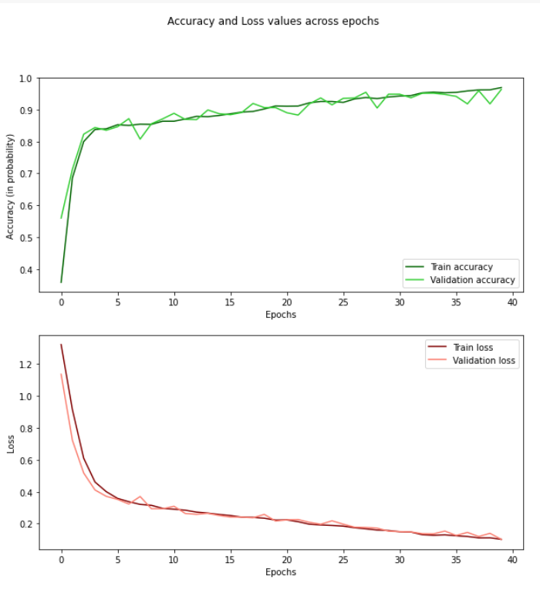

Figure 17 Model 1 accuracy and loss over 40 epochs

Model architecture:

Convolution layer 64 filters, stride = 3,activation=relu

Dropout layer (20% nuerons),

Convolution layer : filters=32, stride=3, activation=relu

GlobalAveragePooling layer

Dense layer ,neurons=4, activation=softmax

optimizer=Adam Optimizer,

loss=categorical crossentropy

Also tride transfer learning with ResNet 50 architecture – Image Net weights: Results were similar to original model so, original model preferred

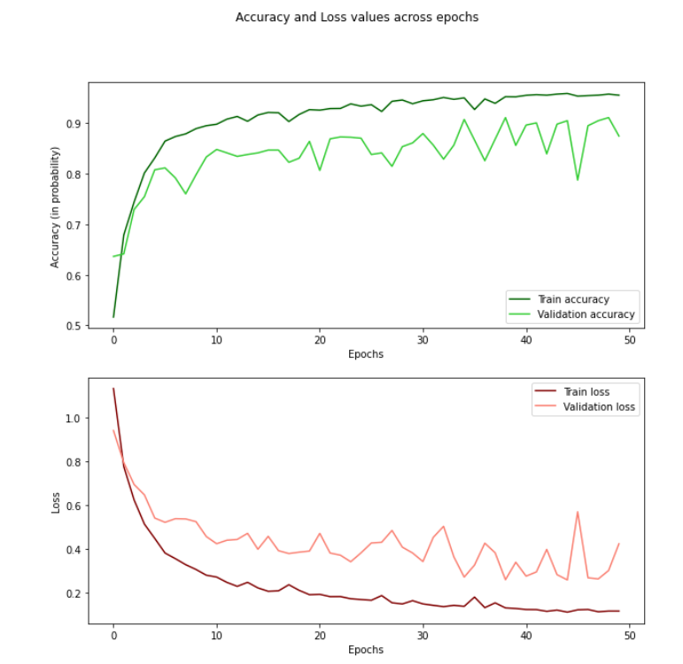

Figure 18 ResNet model accuracy and loss over 50 epochs

loss: 0.1158 - accuracy: 0.9552 - val_loss: 0.4232 - val_accuracy: 0.8744

(Val accuracy for previous model higher, so it was prefered)